|  |
| --- |
| SCOTTISH WATER’S PERFORMANCE 2023-24 |
|  |
|  |
| November 2024 |

Contents

About this document 3

Executive Summary 4

1. Overview of WICS and the 2021-27 Strategic Review of Charges 6

1.1. WICS’ role in the Scottish water industry 6

1.2. How WICS performs its role 6

2. Scottish Water’s funding in 2023-24 8

3. Scottish Water’s expenditure in 2023-24 9

3.1. Capital Investment 9

3.2. Operating and Private Finance Initiative expenditure 10

3.3. Other costs 12

3.4. Cash balance 12

4. The delivery of key outcomes for customers and the environment 14

4.1. Delivery of investment projects 15

4.2. Levels of service 17

4.3. Progress to net zero 22

5. Conclusion 23

# About this document

This report sets out WICS’ assessment of Scottish Water’s performance in the financial year 2023-24, the third year of the 2021-27 regulatory control period.

The report covers six areas:

* WICS’ role in the Scottish water industry;
* how WICS performs this role;
* Scottish Water’s funding in 2023-24;
* Scottish Water’s expenditure in 2023-24;
* what Scottish Water delivered for that expenditure in 2023-24 in terms of levels of service to customers and outcomes for the environment;
* progress towards net zero commitments; and
* conclusions.

# Executive Summary

The Water Industry Commission for Scotland (WICS) is the economic regulator of the Scottish water industry. Each year, we publish an assessment of Scottish Water’s overall performance against the forecasts made during our Final Determination of Charges for the period 2021-22 to 2026-27 and against performance in previous years. This report assesses Scottish Water’s performance in the financial year 2023-24, the third year of the regulatory control period.

For this performance report, we compare Scottish Water’s reported performance in 2023-24 against:

* the allowed-for expenditure from the Final Determination;
* Scottish Water’s measures of progress in delivering the investment programme, levels of service, water quality and environmental performance; and
* Scottish Water’s past performance.

Overall, we welcome that Scottish Water is performing in line with the requirements of the Final Determination in 2023-24 while recognising there is likely to be £500m of less investment than was assumed when charge caps were set. We welcome that Scottish Water has improved its performance on investment delivery to return within its target range for performance. However, we note some areas where Scottish Water is not meeting its own targets, including the delivery of a small number of projects due to be completed in previous regulatory periods, leakage and its new developer Customer Experience Measure. We will continue to monitor Scottish Water’s progress in these areas closely.

The Final Determination set a charge cap of CPI plus 12.6% over the six-year regulatory period, which equates to a cap of CPI plus 2% on average in each year of the regulatory period. By the end of the first three years of the regulatory period, Scottish Water had raised charges by CPI minus 4.4%. This is 10.5% below the assumed position from the Final Determination, largely because Scottish Water responded to the cost-of-living crisis during 2021 and 2022. As a result of the profiling of charges, we expect Scottish Water to have £500m of lower funding available for investment than was assumed in our Final Determination.

Scottish Water incurred £975m (excluding completion investment) on capital investment in 2023-24, around £25m higher than the amount assumed in the Final Determination. This means that Scottish Water has invested around £80m less than forecast in the Final Determination during the first half of the regulatory period (2021-22 to 2023-24).

In last year’s report, we noted that Scottish Water was around a month behind schedule in the measure it uses to track overall progress on investment delivery and around six months behind in completing projects that had started on-site. Scottish Water has made good progress in recovering its position and is now within its target range (of +/-3 months around its forecast) for completing projects that started on-site. It also remains within its target range at an aggregate level.

In last year’s report, we noted that Scottish Water had not met its targets for delivering the investment projects carried forward from the previous regulatory control period covering 2015-21 (known as completion projects). We note that Scottish Water has delivered a further five projects in 2023-24, meaning that it has now delivered 64 of the 86 completion projects. However, this remains short of the 84 Scottish Water expected to deliver by March 2024. Through the Scottish Government Investment Group (SGIG), stakeholders continue to monitor Scottish Water’s progress in this area to ensure that customers get the benefits they have already paid for.

Scottish Water continues outperforming the allowance for operating expenditure and the charges for Private Finance Initiative contracts, with actual expenditure around 3% lower than the allowed-for expenditure. In 2023-24, the primary source of this outperformance relates to a one-off refund of around £25m. Without this one-off refund, Scottish Water’s expenditure would be broadly in line with the allowed-for expenditure.

Figure 1 shows the Scottish Water’s expenditure in 2023-24 by category.

Figure 1: Scottish Water's expenditure in 2023-24

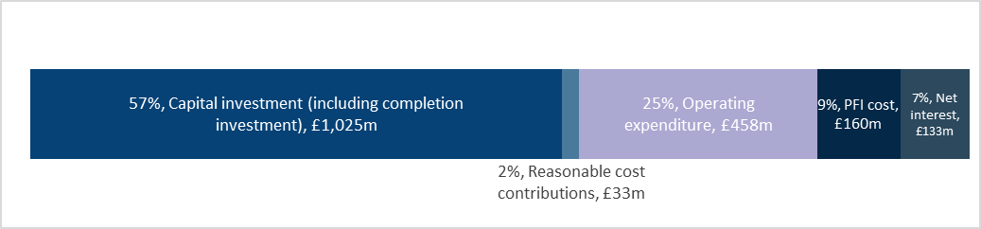

Scottish Water has broadly maintained its levels of service performance in 2023-24. This includes its household and non-household Customer Experience Measures and Outcome Performance Assessment, which covers areas of operational performance such as water interruptions, water pressure, and sewer flooding. Performance in each of these areas is within its target range. However, for the first time in seven years, Scottish Water’s leakage from its network increased, falling outside the upper end of its target range by around 2%.

# Overview of WICS and the 2021-27 Strategic Review of Charges

## WICS’ role in the Scottish water industry

The Water Industry Commission for Scotland (WICS) is the economic regulator of Scottish Water. WICS is a non-departmental public body with an independent Board established through the Water Services Etc. (Scotland) Act 2005.[1] As set out in the Act, WICS has a statutory duty to promote customers’ interests. Fulfilling these duties involves three main activities:

* setting caps on charges for household customers and on wholesale charges for the retailers (known as licensed providers) that serve non-household customers through a process known as the Strategic Review of Charges;
* monitoring Scottish Water’s performance against the forecasts made at the time of setting charge caps; and
* overseeing the orderly functioning of the non-household retail market in Scotland.

This performance report relates to the second main activity above – monitoring Scottish Water’s performance.

## How WICS performs its role

As explained above, WICS sets caps on charges for household customers and wholesale charges for licensed providers through a multi-stakeholder, transparent and consultative process known as the Strategic Review of Charges. The period covered by the Strategic Review of Charges is known as the regulatory control period, which is currently six years. The process ends with WICS confirming these charge caps in a Final Determination before the regulatory control period begins. For example, the Final Determination published in December 2020 set the charge caps to apply over the regulatory control period 2021-22 to 2026-27.[2]

WICS sets charge caps based on its assessment of the lowest reasonable overall cost Scottish Water incurs in delivering the investment priorities set by Scottish Ministers (known as the Ministerial Objectives).[3] These charge caps must also be consistent with the Principles of Charging that Scottish Ministers set. To set these charge caps, WICS forecasts the cash (from revenue and borrowing) that Scottish Water requires to cover the efficient[4] cost of Scottish Water providing water and wastewater services and delivering the investment priorities in Ministerial Objectives.

These forecasts cover three broad categories:

* **Sources of cash:** covering revenue and net new borrowing from the Scottish Government;
* **Uses of cash:** covering the efficient cost of running the business (see the section on the different categories of expenditure) and delivering the investment programme; and
* **Benefits delivered:** covering what customers receive in terms of levels of service performance and tangible deliverables from the investment programme (known as investment outputs or contributions to higher-level outcomes).[5]

Collectively, WICS refers to these forecasts as ‘the baseline’, which is usually provided before the regulatory control period begins.[6] During the regulatory control period, WICS will compare Scottish Water’s reported performance against the forecast values in the baseline and seek to understand any differences. Such monitoring allows WICS to report on whether Scottish Water has delivered the required efficiencies and the investment programme and, ultimately, to hold Scottish Water to account for delivery.

The Strategic Review of Charges 2021 (SRC21) followed a different approach to set the baseline for the investment programme. The baseline for the investment programme was based on top-down allowances, with the expectation that further detail on the investment programme (e.g. on the tangible deliverables) would follow through the then investment planning and prioritisation group (IPPG, which is now part of the Scottish Government Investment Group, SGIG) which would define the investment programme throughout the regulatory period. This is discussed further in Section 4.

In August, we published our draft methodology for the next Strategic Review of Charges 2027 (SRC27), covering the six years from 2027-28 to 2032-33.[7] The draft methodology sets out the importance of Scottish Water submitting a business plan that includes a forward-looking plan for investment as an initial investment baseline. We recognise that the scope and cost of some investment projects may change as they progress through the investment planning process. However, we consider that the flexibility of the investment planning process places the onus on Scottish Water to explain and document any changes to the investment baseline over the regulatory period to enable us and other stakeholders to hold Scottish Water accountable for delivery on behalf of customers.

We will confirm our approach in the final methodology, which we will publish on 12 December 2024.

# Scottish Water’s funding in 2023-24

Scottish Water increased the annual charge by 5% in nominal terms in 2023-24. This represents a reduction of 6.1% in real terms relative to the October rate for the Consumer Price Index (CPI) measure of inflation that is used for setting charges. The increase in Scottish Water’s charges by 8.8% (in nominal terms) in 2024-25 has brought charges broadly back into line with inflation for the SRC21 regulatory control period to date.

Figure 2 shows the cumulative change in charges allowed for in the Final Determination versus the actual change in charges in real terms throughout SRC21.

Figure 2: Cumulative real change in charges in SRC21

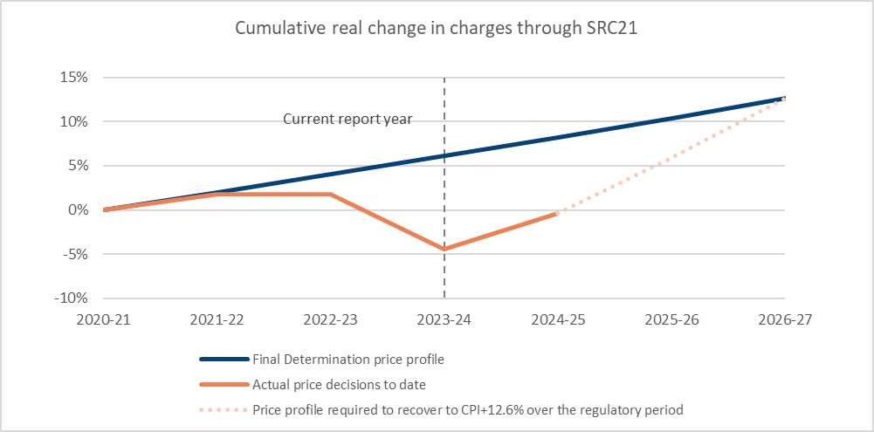

Figure 3 shows the reduction in funding available for capital investment of around £500m due to charging decisions and differences between the inflation forecast of the Final Determination and actual inflation to date in this regulatory control period.

Figure 3: Impact of inflation and price profile on investment through SRC21

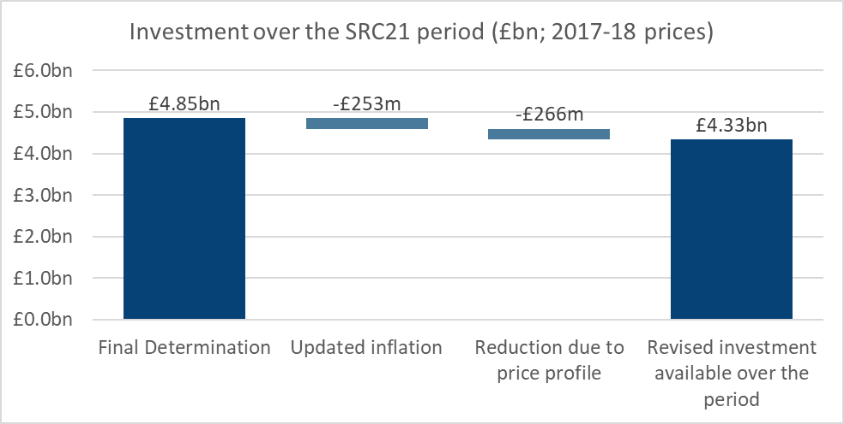

# Scottish Water’s expenditure in 2023-24

Providing essential water and wastewater services requires Scottish Water to spend money in the following areas:

* Capital investment: spending on maintaining, upgrading and building new water sources, treatment plants, pipes, and other equipment required to provide water and wastewater services.
* Operating expenditure: spending on ongoing, day-to-day activities required to provide water and wastewater services.
* Private Finance Initiative (PFI) expenditure: regular payments to third-party organisations providing wastewater assets and services on behalf of Scottish Water under legacy contracts.
* Taxation and interest payments on borrowing.

## Capital Investment

Investment excluding completion was £142m lower in 2021-22 and £37m higher in 2022-23 than that allowed for in the Final Determination.[8] In 2023-24, Scottish Water’s reported investment was £27m higher than that allowed for in the Final Determination. Figure 4 shows the investment in the first three years of the SRC21 period.

Figure 4: Investment excluding completion in SRC27

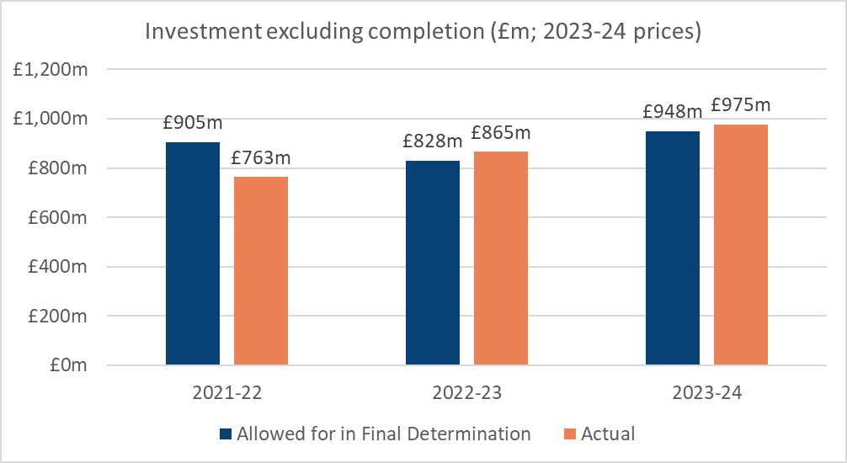

On a cumulative basis, this has resulted in £79m (2023-24 prices) less investment than allowed for in the Final Determination in the period to date. Part of this difference between the allowed-for investment from the Final Determination and reported investment to date relates to how Scottish Water has profiled charge caps in the first three years of the regulatory control period.

## Operating and Private Finance Initiative expenditure

Figure 5 shows that the operating and PFI expenditure of £619m was around £18m (3%) lower than the £637m allowed for in the Final Determination. In 2023-24, Scottish Water received a one-off refund of £24.6m following a successful appeal relating to the rateable value of its water treatment facilities. Without this refund, operating and PFI expenditure in 2023-24 would have been £644m, which is broadly in line (around 1% higher) with the expenditure allowed for in the Final Determination.

Figure 5: Operating PFI expenditure in SRC27[9]

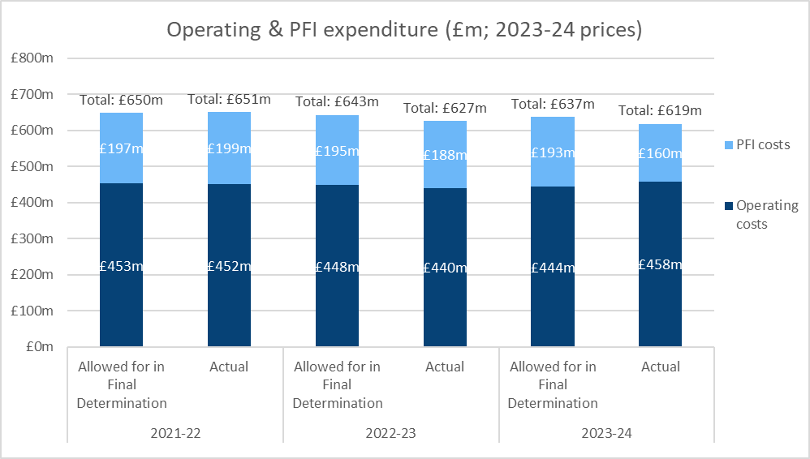

In 2023-24, Scottish Water’s reported operating expenditure included the running costs associated with two PFI schemes (Grampian and Highland) that had since returned to Scottish Water. The allowed for operating expenditure from the Final Determination did not include an adjustment for the return of the PFI schemes. Operating and PFI expenditure was instead considered in aggregate as part of Scottish Water’s recurring annual expenditure, recognising that the expiry of PFI contracts would reduce PFI expenditure, but increase operating expenditure. Figure 6 shows the impact of removing the operating expenditure associated with these schemes to provide a like-for-like comparison with the operating expenditure from the Final Determination. It shows that actual operating expenditure on a like-for-like basis is broadly in line with expenditure allowed for in the Final Determination.

Figure 6: Actual compared to allowed for in Final Determination operating costs in 2023-24 (£m, 2023-24 prices)

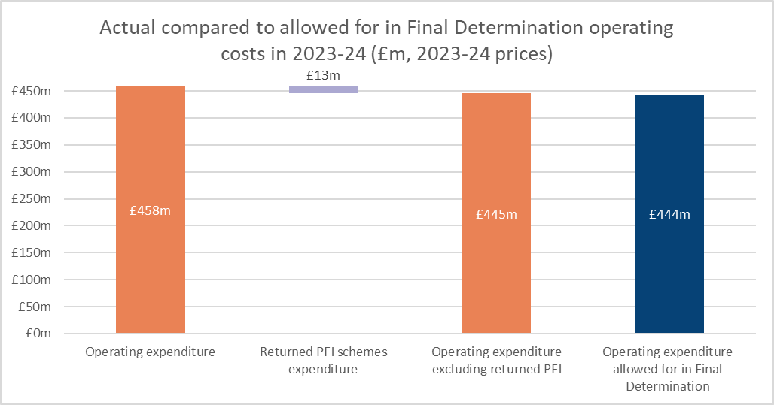

## Other costs

Scottish Water had higher net new borrowing in the year compared to the level assumed in the Final Determination (net new debt of £196m versus £175m assumed in the updated Final Determination).[10]

Scottish Water had lower interest costs in the year than was assumed in the Final Determination, given that it has been able to refinance maturing legacy loans at lower interest rates. Real interest rates on new loans in 2023-24 were also lower than was assumed in the Final Determination.

Scottish Water paid no tax in the year.

## Cash balance

Scottish Water’s cash balance has reduced from £390m in 2022-23 to £280m by the end of 2023-24. This remains higher than the £94m assumed in the Final Determination. Figure 7 provides a reconciliation between the closing cash balance for 2023-24 assumed in the Final Determination and Scottish Water’s reported cash balance of £280m in 2023-24.

Figure 7: Reconciliation between FD cash balance and actual cash balance in 2023-24

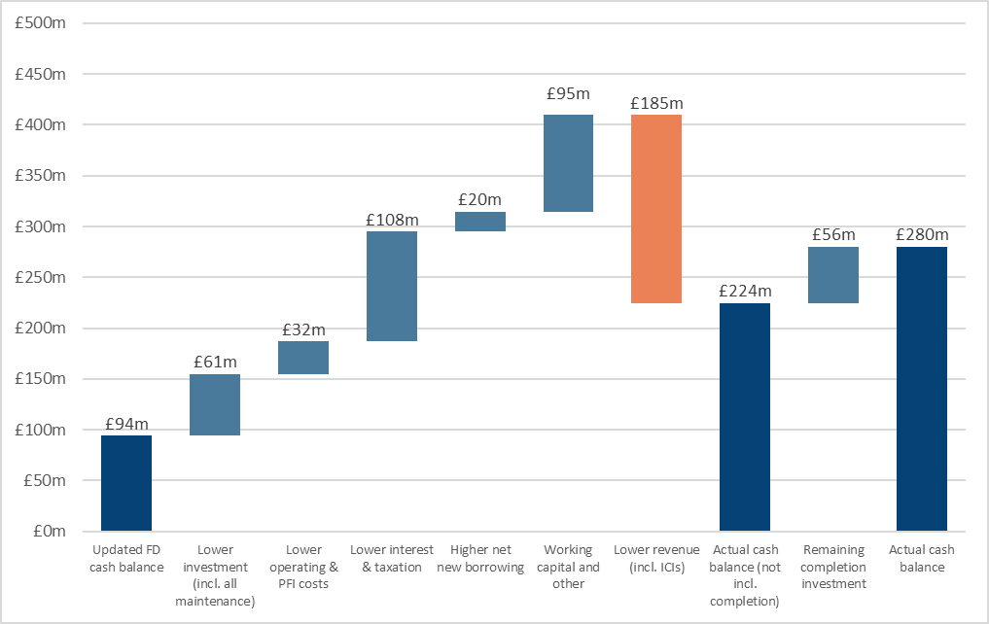

Figure 7 shows the main factors resulting in Scottish Water having a higher cash balance than assumed:

* lower investment of £61m;
* lower operating and PFI expenditure of £32m;
* lower interest and tax paid of £108m;
* higher net borrowing of £20m;
* movement in working capital and other items (e.g. infrastructure charge income and disposal proceeds) of £95m; and
* completion investment from SRC15 programme that is yet to be delivered of £56m.

The combined effect of these factors is offset by Scottish Water having lower revenue than was assumed in the Final Determination of £185m. The lower revenue is the impact of Scottish Water’s charging decisions to date, which has reduced the cash available for investment in outturn prices.

# The delivery of key outcomes for customers and the environment

As outlined in Section 1, a detailed investment baseline was not set at the beginning of the SRC21 period. Instead, the investment baseline was based on top-down allowances for asset replacement investment, enhancement and growth. We expected the detailed bottom-up evidence to follow through the then investment planning and prioritisation group (IPPG, which is now part of the Scottish Government Investment Group, SGIG) which would define the investment programme throughout the regulatory period.[11] This marked a departure from the previous approach, which was based on forward-looking bottom-up evidence of the required investment programme.

Following the final determination, we requested that Scottish Water provide us with an Information Return.[12] This included providing an investment ‘baseline’ or forecast for the remainder of the regulatory control period, covering:[13]

* what Scottish Water is planning to deliver in terms of projects or programmes with tangible investment outputs and measurable contribution to outcomes;
* what benefits will be delivered in terms of improvements to levels of service;
* at what expected cost; and
* by when, with intermediate dates to allow progress to be understood.

Such a ‘baseline’ or forecast would allow stakeholders to understand better:

* future changes to the investment programme, recognising that investment priorities may change as further and better information becomes available; and
* the extent of progress on transitioning towards an increased level of asset replacement investment and any underinvestment in the existing asset base that may be being generated in the meantime and will therefore need to be met by future customers.

Scottish Water has provided a baseline based on its Investment Planning Scenario (IPS) from early 2024 (which Scottish Water defines as IPS 24.1). We will use this IPS to understand and comment on Scottish Water’s performance for the remainder of the SRC21 period.

The draft methodology sets out the importance of Scottish Water submitting a business plan that includes a forward-looking plan for investment as an initial investment baseline. We recognise that the scope and cost of some investment projects may change as they progress through the investment planning process. However, we consider that the flexibility of the investment planning process places the onus on Scottish Water to explain and document any changes to the investment baseline over the regulatory period to enable us and other stakeholders to hold Scottish Water to account for delivery on behalf of customers. The draft methodology for SRC27 has reiterated the importance of the baseline for investment projects.[14]

## Delivery of investment projects

### Indicator of progress on overall delivery

Scottish Water’s Indicator of Progress on Overall Delivery (IPOD) provides a high-level measurement of Scottish Water’s progress in delivering the projects over £1m. It assesses the progress of these investment projects monitored across 3 delivery gates: Start-on-site (SOS), Acceptance (Gate 100), and Financial Completion (Gate 110). When a project passes a gate, 1 point is added to the IPOD measure. The overall capital programme is considered ‘on track’ if the IPOD score is within the target range. The lower and upper limit of the target range is the IPOD score of the previous and subsequent quarter respectively based on Scottish Water’s forecasts when the projects were added to the Committed List. This means that the target range represents +/- 3 months around Scottish Water’s delivery forecasts.

The IPOD indicator as of 31 March 2024 was 889 points, against a range of 819 to 937 points. The IPOD score for each of the constituent gates is also within the respective target ranges for these gates, as set out below:

* **Start-on-site:** The IPOD score for the start-on-site date has consistently met the target during the SRC21 period.
* **Project acceptance:** The IPOD score for Acceptance (Gate 100) has been below the target range since Quarter 3 of 2021-22. This indicates that completing projects once they have started on site has consistently taken more time than Scottish Water had forecast initially. However, as of Quarter 3 of 2023-24, Scottish Water is now within the target range.
* **Financial completion:** The IPOD score for Financial Completion (Gate 110) has been mostly within the target range during the SRC21 period except for Quarters 2 and 3 of 2023-24; however, it is now back on track.

These movements can be seen inFigure 8 below.

Figure 8: Investment delivery against the Scottish Water baseline

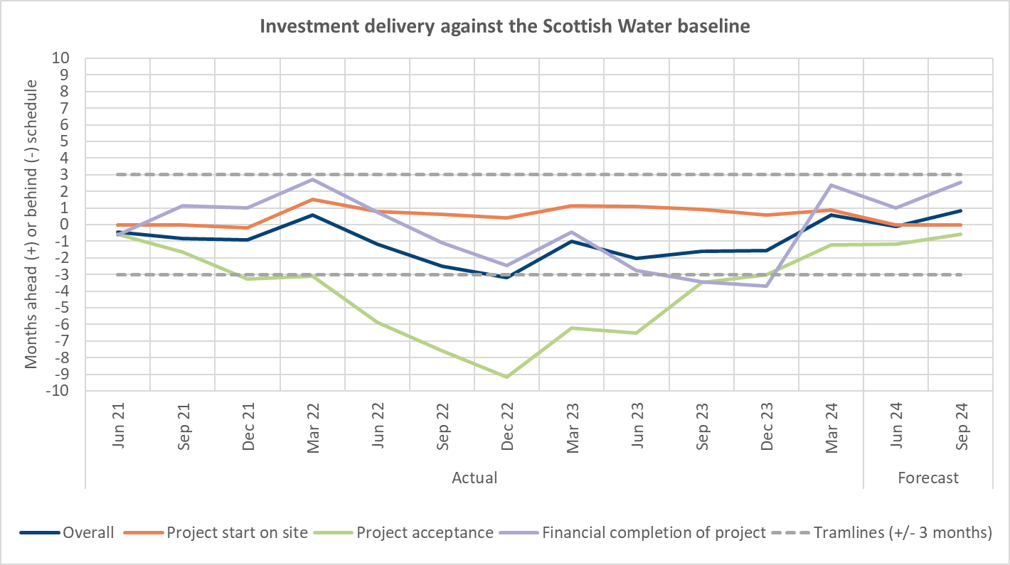

### Completion investment

Completion investment relates to investment included in the investment programme for the Strategic Review of Charges 2015 (SRC15) but is still to be delivered. There are two categories of SRC15 completion projects:

* Delayed Projects – projects that were expected to complete by the end of SRC15 but were impacted by Covid-19, re-optioneering, scope change, construction risk and third-party risk.
* Planned Projects – projects that commenced in SRC15 but were always expected to complete during SR21.

Table 1: Completion investment

|  |  |  |
| --- | --- | --- |
|  | **Delayed** | **Planned** |
| Total remaining projects at 31 March 2021 | 86 | 57 |
| March 2021 forecast for completed projects by 31 March 2024 | 85 | 55 |
| Actual completed projects by 31 March 2024 | 64 | 48 |
| Actual less forecast number of projects to be completed by 31 March 2024 | -21 | -7 |

The remaining completion investment represents around 2% of the total SR15 programme. Scottish Water provided an update on the remaining completion projects to the SGIG working group in August 2024. In the presentation,[15] it explained that a third of the outstanding projects are in construction and proceeding without expectation of further delay. The remaining projects are experiencing delivery delays due to various reasons, such as changes in the scope of work, operational factors, and third-party factors.

Scottish Water holds regular bilateral meetings with DWQR and SEPA, where projects of specific interest to these stakeholders, including SRC15 completion projects, are reviewed to give detailed updates on progress and answer any queries. Progress on these projects is also examined through the SGIG.

## Levels of service

### Customer experience

The Customer Experience Measure (CEM) is a measure of Scottish Water’s service which combines a qualitative survey-based component, with a quantitative component measuring the number of complaints and whether customers have escalated complaints. Scottish Water has separate CEM measures for households, non-households (i.e. licensed providers and business end-users) and developer services.

Scottish Water has broadly maintained its performance on its household and non-household CEMs. The actual scores for these measures are shown against the annual targets (baseline) in Figure 9 and Figure 10 for households and non-household CEMs respectively.

Figure 9: Household CEM

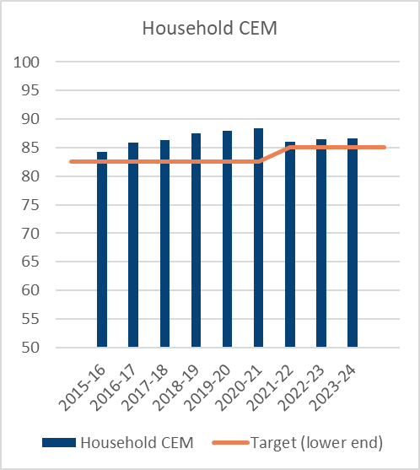

Figure 10: Non-household CEM

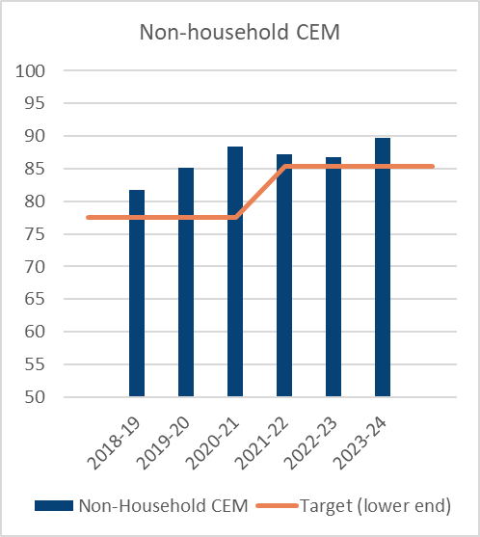

Scottish Water has trialled a Developer CEM over recent years with the measure becoming live in 2023-24. Figure 11 shows that Scottish Water’s performance of 75.9 was outside of the lower end of the target range for dCEM of 76.5-78.7.

Figure 11: Developer CEM

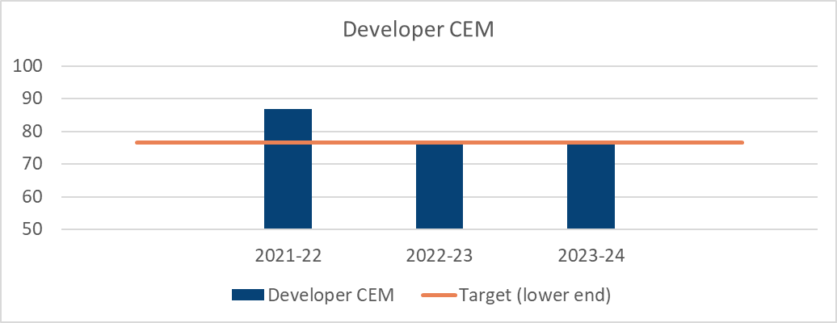

### Outcome Performance Assessment

Scottish Water measures its overall performance through an Outcome Performance Assessment (OPA) which is a weighted index of nine measures covering the water service, wastewater service and the impact of services on the environment.

In 2023-24, Scottish Water reported a score of 402 (89% of points available) against a target range of 395 – 410 points. This is similar to scores in 2021-22 and 2022-23, as shown in Figure 12.

Figure 12: OPA

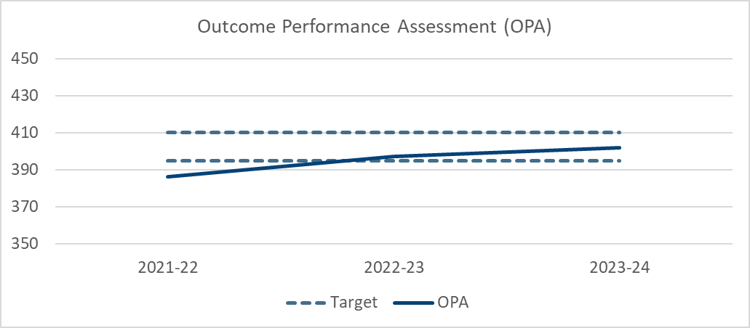

Scottish Water has maintained its performance across all measures. Performance against environmental pollution incidents (EPIs) category 1 & 2 has slightly improved, but this was offset by slight decreases in drinking water quality, interruptions to supply and leakage. Drinking water quality remains high, with 99.9% of samples complying with regulations.

Scottish Water reported leakage of 462 Ml per day, an increase of 8Ml/d compared to the previous year and higher than the target range of 438 – 453. This is the first time leakage has increased since 2007.[16]

Table 2 shows performance across all measures.

Table 2: OPA measures performance

|  |  |  |  |  |  |
| --- | --- | --- | --- | --- | --- |
| Indicator | Definition | Performance range to achieve minimum and maximum score | 2021-22 | 2022-23 | 2023-24 |
| Total Drinking Water Quality | Percentage of water samples that comply with parameters | 99.522% - 99.978% | 99.936% | 99.929% | 99.923% |
| Interruptions To Supply | Percentage of connected properties experiencing unplanned interruptions | 1.768% - 0.057% | 0.34% | 0.20% | 0.23% |
| Poor Pressure | Properties per 10,000 water connections subject to inadequate water pressure | 11.947 - 0.165 | 0.163 | 0.169 | 0.139 |
| Leakage | Actual leakage (Ml/d) | 1046.16 - 400 | 458.39 | 453.71 | 461.84 |
| Internal Sewer Flooding | Number per 10,000 connected wastewater properties suffering internal sewer flooding caused by overloading and other causes | 16.72 - 0.4 | 1.55 | 1.37 | 1.43 |
| EPIs (Category 1 & 2) | Weighted number of water and wastewater environmental pollution incidents (category 1 and 2) incidents per 10,000km of sewer network[17] | 4.226 - 0.149 | 1.119 | 1.291 | 1.006 |
| EPIs (Category 3) | Weighted number of water and wastewater environmental pollution incidents (category 3) incidents per 10,000km of sewer network [18] | 1.225 - 0.1013 | 0.5205 | 0.3781 | 0.3620 |
| Wastewater Compliance | Number of non-compliant wastewater treatment works out of 1428 treatment works | 131.3 - 6.5 | 20 | 22 | 22 |
| Sludge Compliance | % of sludge disposed of satisfactorily | 98.22% - 100% | 100% | 100% | 100% |

### horizon scanning on scottish water’s performance

The Drinking Water Quality Regulator (DWQR) publishes its report on Scottish Water’s performance covering each calendar year. The most recent report covering calendar year 2023 was published in October 2024. The report confirms that “data shows a continued high level of compliance with standards”.[19]

In September 2024, Environmental Standards Scotland published an assessment of spills from storm overflows and their impact on the water environment.[20] These relate to spills from about 4,080 intermittent discharges, including combined sewer overflows and emergency overflows, designed to prevent property sewer flooding during heavy rainfall.

As part of its Improving Urban Waters Routemap,[21] Scottish Water has made commitments to:

* improve water quality by addressing the high priority discharges impacting water quality and causing sewage related debris in support of Scotland’s River Basin Management Planning Objectives;
* increase monitoring by installing 1,000 spill monitors by 2024;
* reduce wastewater debris; and
* reduce spills.

Through SGIG, we will monitor Scottish Water’s progress in delivering this part of the programme. We are working with Scottish Water and stakeholders to develop outcome measures in this area that cover Scottish Water’s commitments under the Improving Urban Waters Routemap.

## Progress to net zero

Scottish Water has a target to achieve overall net zero emissions by 2040. This target of net zero emissions by 2040 applies to operational emissions and all emissions associated with the capital investment programme. As a stepping stone on its journey towards net zero, Scottish Water's Net Zero Routemap established interim milestones to reduce operational emissions by at least 60% (from the 2007 baseline) by 2025 and by at least 75% by 2030.[22] The 2030 milestone was set to align with the previous Scotland-wide target, which has been superseded by a carbon budget approach to setting climate targets.[23]

Figure 13 shows Scottish Water’s progress in reducing its operational carbon emissions compared to the 2006-07 baseline. In 2023-24, Scottish Water has reduced its operational carbon emissions by around 50% compared to the 2006-07 baseline.

Figure 13: Reduction in operational emissions from 2007 baseline

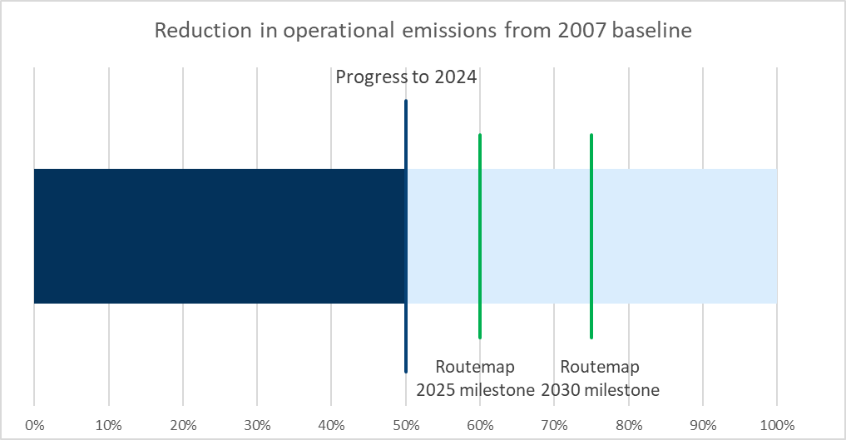

Scottish Water has explained that it continues to work towards a 60% reduction in operational carbon emissions and achieving net zero by 2040 but has made slower progress due to factors, including:

* slower than forecast decarbonisation of the electricity grid, which affects the electricity emissions profile reported by Scottish Water; and
* a moratorium on new solar schemes, until Scottish Water secures a supplier that can fully verify that materials sourced comply fully with modern slavery expectations.

We will continue to engage with Scottish Water, the Scottish Government and other stakeholders on Scottish Water’s milestones for achieving net zero as part of SRC27.

# Conclusion

Overall, we conclude that Scottish Water is performing in line with the requirements of the Final Determination in 2023-24 while recognising there is likely to be £500m of less investment than was assumed when charge caps were set. We welcome that Scottish Water has improved its performance on investment delivery to move back into its target performance range. We note some areas where Scottish Water is not meeting its own targets, including the delivery of a small number of projects due to be completed in previous regulatory periods, leakage and its new developer Customer Experience Measure. We will continue to monitor Scottish Water’s progress in these areas.

1. The Water Services etc. Scotland Act 2005, available at <https://www.legislation.gov.uk/asp/2005/3/>
2. WICS (2020), ‘2021-27 Final Determination', available at <https://wics.scot/publications/price-setting/strategic-review-charges-2021-27/determinations/2021-27-final-determination>.
3. Scottish Government (2020), ‘Scottish Water: directions 2020’, December, available at: <https://www.gov.scot/publications/scottish-water-directions-2020/>
4. An improvement in efficiency is defined as either a reduction in costs with no deterioration in service; or maintaining costs, while improving service.
5. Outputs are tangible deliverables provided by an investment project, driven by legislative or other requirements, which will contribute toward meeting investment drivers or outcomes. Outcomes are higher level objectives that customers and society value – for example, a clean water environment.
6. SRC21 followed a different approach, with allowances for investment based on top-down allowances rather than bottom-up evidence of forecast expenditure, tangible deliverables and milestones for delivery.
7. WICS (2024), ‘*Strategic Review of Charges 2027-2033: Draft Methodology*’, 14 August 2024. Available at <https://wics.scot/publications/price-setting/strategic-review-charges-2027-33/approach/2027-33-methodology>.
8. Both values are expressed in 2023-24 prices.
9. Totals may not appear to be the sum of operating costs and PFI costs due to rounding.
10. The Final Determination set assumptions for net new borrowing, which relates to the borrowing raised in the year net of the borrowing repaid in the year.
11. WICS (2020), *‘Strategic Review of Charges 2021-27: Final Determination’*, 10 December 2020, pp.15-16.
12. WICS (2022), ‘*SRC21 Letter - Information request*’, 10 March 2022. Available at <https://wics.scot/publications/price-setting/strategic-review-charges-2021-27/regulatory-information-requests/src21-letter-information-request>
13. WICS (2023), ‘*SRC21 Letter – Reporting quality improvement plan*’, 21 March 2023. Available at <https://wics.scot/publications/price-setting/strategic-review-charges-2021-27/regulatory-information-requests/src21-letter-reporting-quality-improvement-plan>
14. WICS (2024), ‘*Strategic Review of Charges 2027-2033: Draft Methodology*’, 14 August 2024. Available at <https://wics.scot/publications/price-setting/strategic-review-charges-2027-33/approach/2027-33-methodology>.
15. Presented at Scottish Government Investment Group Working Group 21st meeting on 21 August 2024, Item 6.
16. Scottish Water (2024), ‘2023-24 Section A Commentary’, p.25. To be published in December 2024 on <https://wics.scot/publications/scottish-water/annual-return-regulatory-accounts>
17. Pollution incidents are classified according to their impact on the environment and people, from category 1

    (the most serious) to category 4 (little or no impact) and the level of response needed.

    Weighted number of water and wastewater environmental pollution incidents (categories 1 and 2) is calculated as 0.5*wastewater incidents + 1*water incidents.
18. Weighted number of water and wastewater environmental pollution incidents (category 3) is calculated as 0.01*wastewater incidents + 0.02*water incidents.
19. DWQR (2024), *‘Drinking Water Quality in Scotland 2023 DWQR Annual Report – Public Supplies’*, October, p.6.
20. Environmental Standards Scotland (2024), *‘Storm overflows – an assessment of spills, their impact on the water environment and the effectiveness of legislation and policy’*, September.
21. Scottish Water, *‘Improving Urban Waters Routemap Annual Update’.*
22. Scottish Water (2020), *‘Net Zero Emissions Routemap’,* September, p.10.
23. Scottish Government (2024), ‘Climate Change Bill passed’, November, available at: <https://www.gov.scot/news/climate-change-bill-passed/>, last accessed 21 November 2024.